**19CSE401 Compiler Design Lab**

Anindita Das Badhan

CH.EN.U4CSE22180

CSE-B, 4th year

**Lab Exercises -01**

**1. Aim**: To write a program that identifies and counts words in an input sentence.

**Program:**

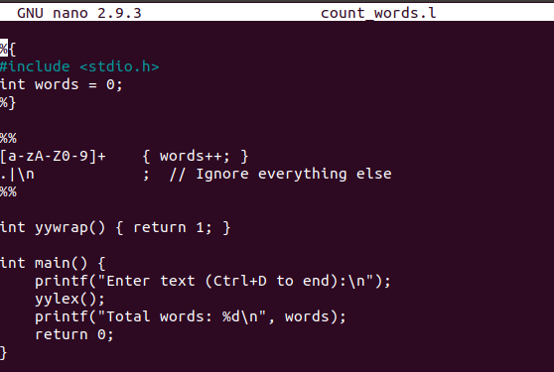

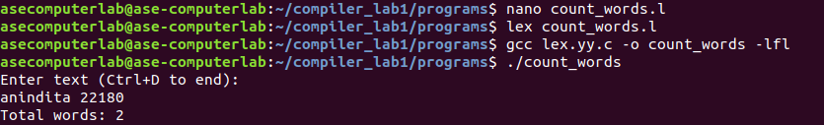**Output:**

**2. Aim**: To write a program that checks whether a given number is odd or even.

**Program:**

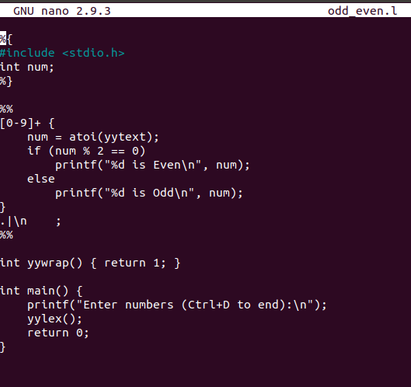

**Output:**

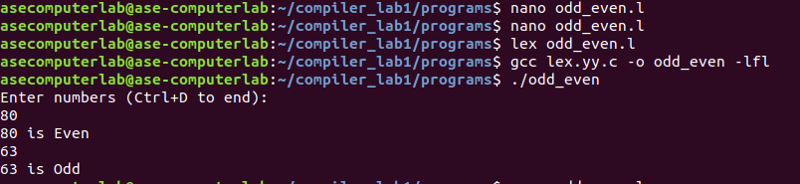

**3. Aim**: To write a program that identifies and counts vowels in each character or string.

**Program**:

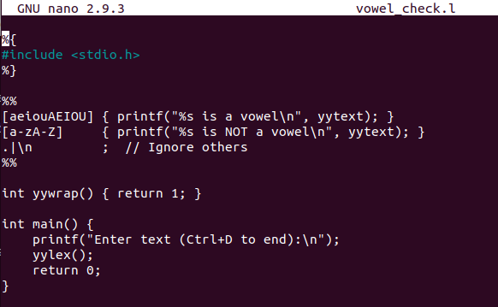

**Output:**

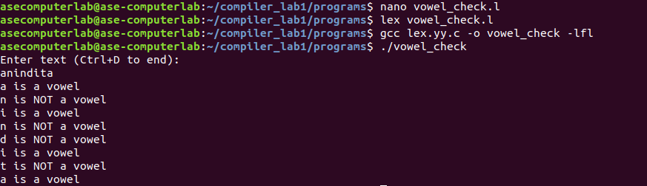

**4. Aim**: To write a program that determines whether a given number is positive or negative.

**Program:**

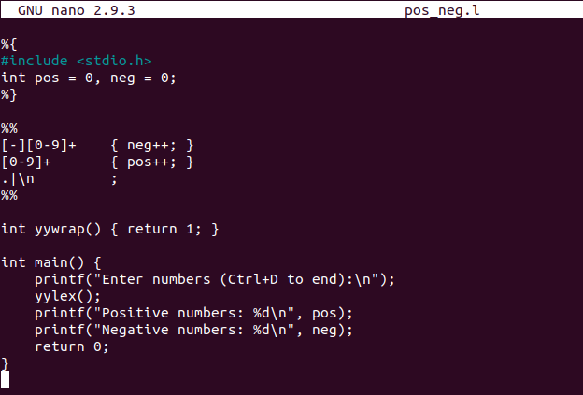

**Output**:

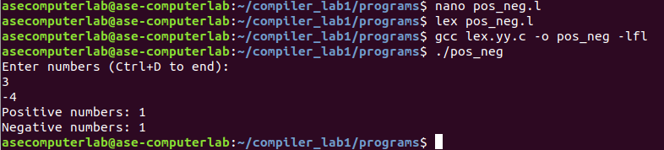

**5. Aim:** To write a program that calculates the sum of the digits of a given number.

**Program:**

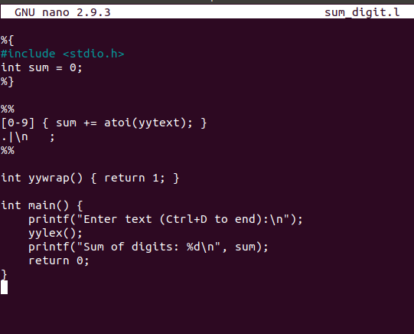

**Output**:

